https://www.perutravelexpertsb.com/tours/inka-trail-2d

ROYAL INKA TRAIL
2 DAYS

DAY 1. OLLANTAYTAMBO – KM 104 - MACHU PICCHU.
We pick you up from your hotel at 06:30 am and walk to the train station at Ollantaytambo. We travel 1 hour 30 minutes by train to Km 104(2050m/6,725ft) the start of the trail. After we show our original passports and cross the checkpoint, we will walk up approximately 4 hours to the Inca site Wiñay Wayna ('Forever Young') at 2650m/8,694ft. On the way, we will have many breaks to enjoy the spectacular views. After exploring the Inca site, we will have time for our lunch, then we will continue for about 1 hour to 'Inti Punku' (Sun Gate) at 2720m/8,923ft where we will have the first panoramic view of Machu Picchu (2400m/7,874ft) then we will walk down to Machu Picchu and to go by bus down to Aguas Calientes for dinner and the night. You can also go to the thermal springs.
Overnight in Aguas Calientes.
- Trekking distance: 14 km/8.69 miles
- Aguas Calientes: 2'040m/6'692ft

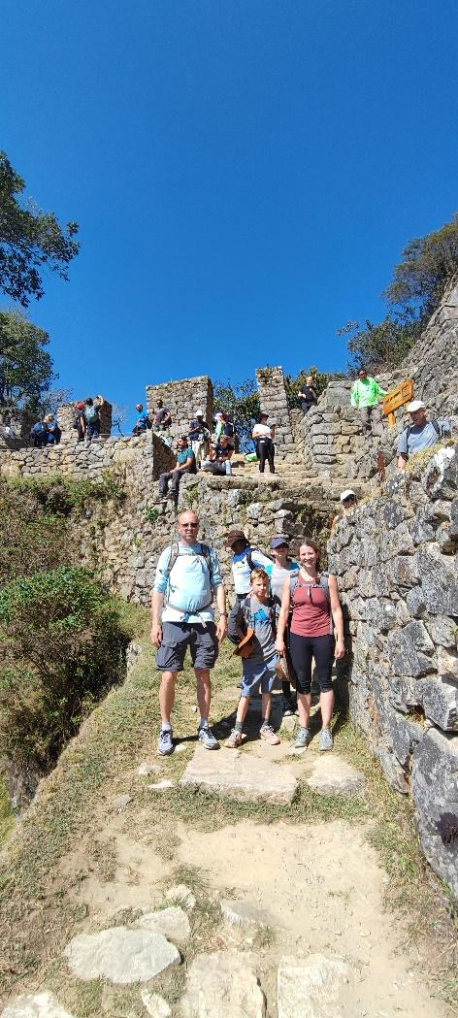
CHACHABAMBA
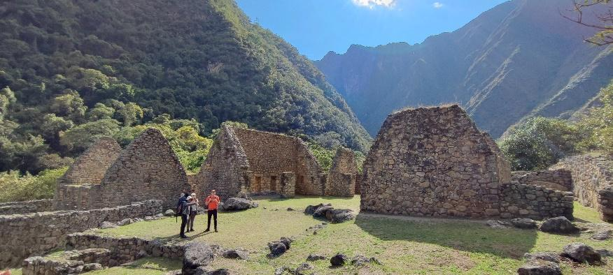

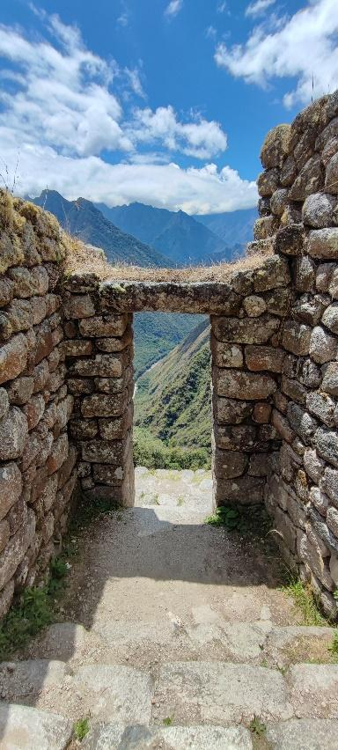

SUN GATE
WIÑAYWAYNA

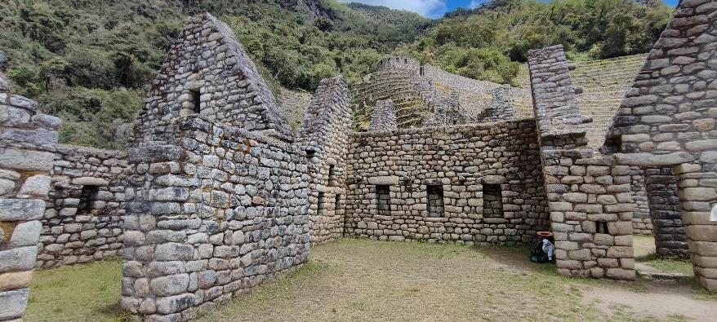

Details
Departure Location.
Your hotel in Ollantaytambo or Cusco City.
End Location.
Hotel in Aguas Calientes Town (Machu Picchu pueblo).
Departure Time.
Services start:
04:00am from Cusco
06:00 am from Ollantaytambo or Urubamba.
What’s Included.
- Pick-up: at your hotel.
- Private transportation to the Ollantaytambo train station.
- Train Tickets from Ollantaytambo to Km 104 (start of the trek).
- Entrance tickets to the Inca Trail and entrance tickets to Machu Picchu.
- Bus Tickets from Machu Picchu to Aguas Calientes Town.
- English-speaking professional Tour Guide.
- Meals: Box Lunch for the trek.

What’s NOT included.
- Hotel in Aguas Calientes Town.
- Personal expenses and anything other than what are on the program.
- Meals: Breakfast and Dinner.
- Gratuities.

Suggestions and Restrictions.
Comfortable walking shoes, Mosquito repellent, Sun Protection or rain ponchos, depending on the season, hat, Snacks, and a lot of curiosity.

Please note that no porters are used on this trek. We recommend you to have a back pack of 34 Ltrs to carry
your water, snack and your Box Lunch. For the rest of your staff, we will give you a duffle where you can put
one Change of clothes to change into the next day. This duffel will be send to your hotel in the town of Aguas
Calientes.

DAY 2. AGUAS CALIENTES - MACHUPICCHU.
You woke up early this morning to; have breakfast in the hotel and then take one of the first buses to Machu Picchu. It is well worth the effort to arrive at Machu Picchu early because the Inca City is quietest in the early morning, and we will have time to take photos and enjoy the sunrise over Machu Picchu. Your guide will take you to the classic spot to take your postcard pictures. This vantage point offers a terrific view of the whole complex; then, you will have a guided tour of Machu Picchu, learning about the history of Machu Picchu and seeing the most important buildings and temples.
Once you feel that you have seen every corner of Machu Picchu, you will take a bus back down to Aguas Calientes Town, where we will have time to enjoy your lunch, then you will get your train to return to Ollantaytambo Town and private car back to your hotel in Cusco.
Overnight in Cusco.
- Total distance by bus 6km/3.37miles
- Machu Picchu altitude 2'400m/7'874ft

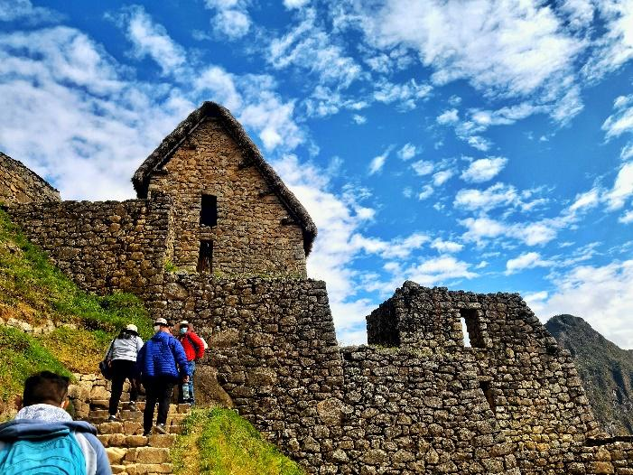
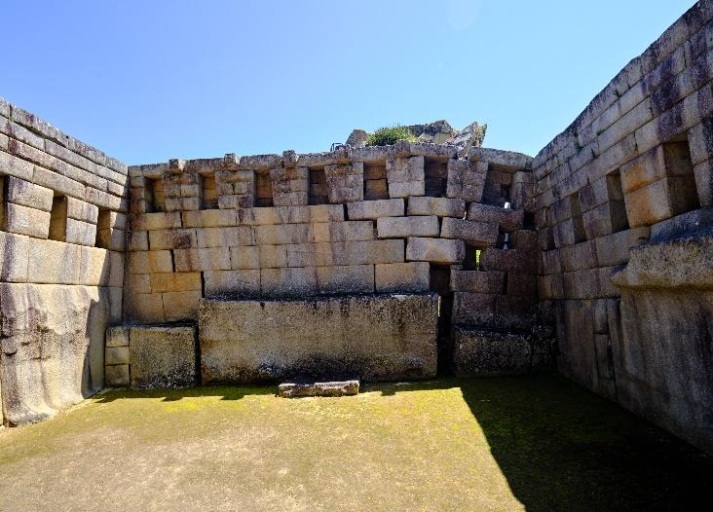

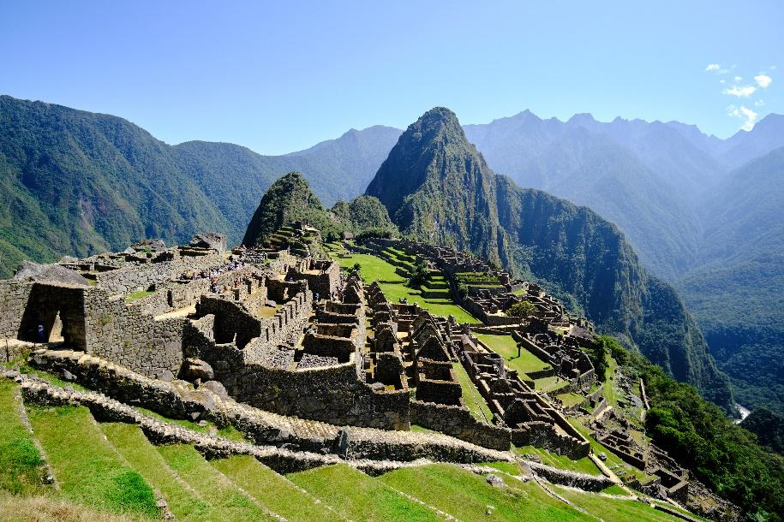

Details
Departure Location.
Your hotel in Aguas Calientes Town.
End Location.
Hotel in Cusco City.
Departure Time.
Services start at 06:30 am.

What’s Included.
- Pick-up: at your hotel in Aguas Calientes.
- Bus Tickets round trip from Aguas Calientes Town to Machu Picchu.
- Entrance tickets to Machu Picchu. (Second time)
- Train Tickets from Aguas Calientes Town to Ollantaytambo.
- Private transportation from Ollantaytambo train station to Cusco City.
- English-speaking professional Tour Guide.

What’s NOT included.
- Personal expenses and anything other than what is on the program.
- Hotel in Cusco City.
- Meals: Breakfast, Lunch and Dinner.
- Gratuities.

Suggestions and Restrictions
One-day backpack to carry your water, snacks and passport.
Comfortable walking shoes, Mosquito repellent, Sun Protection or rain ponchos, depending on the season, hat, Snacks, and a lot of curiosity.
Ticket for Wayna Picchu and Machu Picchu Mountain. If you would like to climb either of these mountains, please tell us in the remarks field while booking. The additional cost is USD 75.
CONDITIONS FOR THE PROVISION OF THE SERVICE.

- Price of all groups expressed in US dollars.
- Private Service, exclusive for the group or person who hires the service.
- Service is subject to availability at the time of confirming the reservation.
- Non-refundable, the client can request the date change up to 30 days in advance; otherwise, it will be considered a NO SHOW, and there will be no option to reschedule.
- Participants must follow the tourism health protocols that include the use of a mask during transfers, constant hand disinfection with alcohol, a distance of 1.5 meters, and others that will be informed at the time-of-service provision.

BOOKING PROCESS

BOOKING
To reserve your trip to Peru you must make a deposit of 50% of the total price of the trip and send a
photo of the deposit and the next important personal information or you can send a photo of the passports of each traveler in the group.

First name:
Last name:
Passport number:
Date of birth:
Passport expiration date:

The remaining 50% of the trip you will pay it in Cusco in US dollars before starting your tour.
To make the payment of the remaining balance, you can pay in CASH and in Dollars or pay with a
credit or debit card, however if you pay with a card, we must add 7% more for the transfer cost.

CANCELLATIONS.
To cancel your trip, keep in mind the following.
If your trip includes hotels, you can cancel 2 months before your trip begins in Peru.
If your reservation does not include hotels, you can cancel 1 month before starting your trip in Peru.
In both cases, only 70% of the deposit will be refunded. The remaining 30% will be used for administrative expenses and refund transfer expenses.

TOTAL COST PER TRAVELER IN $-USD. 2 DAYS TOUR IN CUSCO
NOT HOTELS INCLUDED (1 nights).

2-3 PEOPLE | 4-5 PEOPLE | 6-7 PEOPLE | 8 to more PEOPLE
$ 999 | $ 879 | $ 849 | $ 819

